
VIETNAM NATIONAL UNIVERSITY - HCM
UNIVERSITY OF INFORMATION TECHNOLOGY

FACULTY OF INFORMATION SYSTEMS

Lab 2

Class: IS403.O21.HTCL

Inferential Statistics

Instructed by: Assoc. Prof., Dr. Nguyen Dinh Thuan

Conducted by:
Phan Chi Cuong - 21520673
Nguyen Le Khang - 21520960
Le Pham Quoc Bao - 21521849

Ho Chi Minh, March 20th, 2024.

Table of Contents
1.1 Levene Test for Equality of Variance 4
1.2 Post hoc comparisons in ANOVA 6
1.1.1 What are post hoc comparison tests used for in ANOVA ? 6
1.1.2 Example 6
1.3 Perform Chi Square test on the independence of two categorical variables with the dataset Energy Drink Survey 7
1.3.1 Using Excel 7
1.3.2 Using Python 10
1.3.3 Using R 11
1.4 Perform ANOVA with Insurance survey dataset 13
1.4.1 Levene’s Test 13
1.4.1.1 Using Python 13
1.4.1.2 Using R 13
1.4.2 Anova’s Test 13
1.4.2.1 Using Excel 13
1.4.2.2 Using Python 15
1.4.2.3 Using R 15
1.4.3 Turkey Test 15
1.4.3.1 Using excel 15
1.4.3.2 Using Python 16
1.4.3.3 Using R 17
1.4 ANOVA with Vietnam National Highschool Score 2023 dataset 17
1.4.1 Using Python 18
1.4.2 Using R 19
REFERENCE 20

Table of Figures
Figure 1. F-distribution table for alpha = 0.05 6
Figure 2 Import data and necessary library 10
Figure 3 Create contingency table 11
Figure 4 c-value, p-value, degrees of freedom, expected of the test 11
Figure 5 Import dataset and install necessary library 11
Figure 6 Create contingency table 12
Figure 7 c-value, p-value, degrees of freedom 12
Figure 8. Preview data after processing 18
Figure 9. The summary of ANOVA test 19
Figure 10. Preview data after processing 19
Figure 11. The summary of the ANOVA test 20

WORK DISTRIBUTION

Members  Works | Phan Chi Cuong  (Leader) | Nguyen Le Khang | Le Pham Quoc Bao
Problem statement |  |  | 
Build the report template | 
Do exercise 1a | 
Do exercise 1b |  | 
Do all exercise 2 |  |  | 
Do all exercise 3 |  | 
Do all exercise 4 | 
Summarize and edit reports |  |  | 
Completion (%) | 100% | 100% | 100%

Lecturer's comment

1.1 Levene Test for Equality of Variance

The Levene Test for Equality of Variances is a statistical test used to check if the variances are equal for all samples when your data comes from a non-normal distribution. It’s often used to verify the assumption of equal variances before running a test like One-Way ANOVA.
The null hypothesis for Levene’s test is that the variances are equal across all samples. In more formal terms, that’s written as
- The null hypothesis ($H_{0}$) for Levene’s test is that the variances are equal across all samples.
- The alternate hypothesis ($H_{1}$), is that the variances are not equal for at least one pair.
The result from the test is reported as a p-value, which you can compare to your alpha level for the test. If the p-value is larger than the alpha level, then you can say that the null hypothesis stands — that the variances are equal; if the p-value is smaller than the alpha level, then the implication is that the variances are unequal.
alpha level: also known as the significance level, is a threshold set by the researcher before conducting a statistical test. The most used alpha level is 0.05 or 5%. This means that there is a 5% chance of rejecting the null hypothesis when it is true. In other word, its value is determined based on the level of risk the researcher is willing to accept.
For instance, the alpha level is 0.05:
- If the p-value $≥$ 0.05, then you can say that the null hypothesis stands — that the variances are equal.
- If the p-value < 0.05, then the implication is that the variances are unequal.
Practical examples:
Suppose we have three different teaching methods, and we want to know if they result in different variances in student scores. We have three groups of students, each taught by a different method, and we measure their final scores. Here are the scores:
- Individual learning: 85, 90, 78, 92, 88
- Group learning: 80, 85, 88, 92, 94
- Lecture-based learning: 91, 92, 93, 94, 95
First, we need to calculate the mean value of student's scores in each method.
- Individual learning: 86.6
- Group learning: 87.8
- Lecture-based learning: 93
Then, calculate absolute differences.
- Individual learning absolute differences: |85 - 86.6|, |90 - 86.6|, |78 - 86.6|, |92 - 86.6|, |88 - 86.6|
- Group learning absolute differences: |80 - 87.8|, |85 - 87.8|, |88 - 87.8|, |92 - 87.8|, |94 - 87.8|
- Lecture-based absolute differences: |91 - 93|, |92 - 93|, |93 - 93|, |94 - 93|, |95 - 93|
- Individual learning absolute differences: 1.6, 3.4, 8.6, 5.4, 1.4
- Group learning absolute differences: 7.8, 2.8, 0.2, 4.2, 6.2
- Lecture-based absolute differences: 2, 1, 0, 1, 2
From absolute difference, we can calculate mean absolute difference for each method:
Individual learning mean absolute difference: (1.6 + 3.4 + 8.6 + 5.4 + 1.4)/ 5 =4.08
Group learning mean absolute difference: (7.8 + 2.8 + 0.2 + 4.2 + 6.2) / 5 = 4.24
Lecture-based learning mean absolute difference: (2 + 1 + 0 + 1 + 2) / 5 = 1.2

Next, calculate the grand mean, which is the mean of all the mean absolute differences:
Grand mean: (4.08 + 4.24 + 1.2) / 3 = 3.173
Now, we calculate the sum of squares, which is the sum of the squared differences between the mean absolute difference and the grand mean for each group:

Sum of squares: ${(4.08 - 3.173)}^{2}+ {(4.24 - 3.173)}^{2} + {(1.2-3.173)}^{2}= 3.68$

Finally, we calculate the test statistic, which is the sum of squares divided by the total degrees of freedom. The degrees of freedom are the total number of groups minus 1.
Test statistic: 3.68 / (3 - 1) = 1.84
Result evaluation:
To assess the test statistic value, we need to know DF1 and DF2 value.
- DF1 (numerator degrees of freedom): The number of groups minus 1. In my example, I have 3 teaching methods, so DF1 = 3 - 1 = 2.
- DF2 (denominator degrees of freedom): The total sample size minus the number of groups. In my example, I have 15 students in total and 3 groups, so DF2 = 15 - 3 = 12.
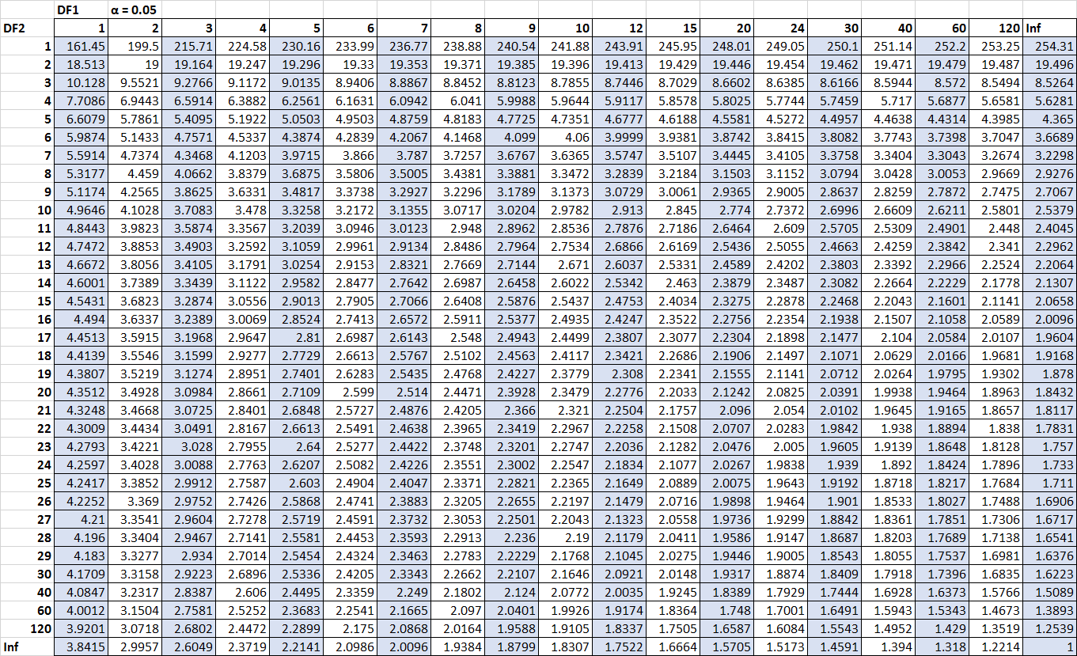
Figure 1. F-distribution table for alpha = 0.05
We can easily notice that test statistic smaller than critical value of F-distribution table (df1=2, df2=12) as 1.84<3.88. This suggests that there is not enough evidence to conclude that there is a significant difference in the variances of student scores across the three teaching methods.

1.2 Post hoc comparisons in ANOVA

What are post hoc comparison tests used for in ANOVA ?

- The Analysis of Variance (ANOVA) can determine whether there is a statistically significant difference between the means of multiple groups, but it cannot identify which specific groups differ from one another.

- Post hoc comparison tests play the following roles: revealing specific differences: ANOVA provides a broad overview; post hoc tests enlarge the picture, revealing which pairs of groups have statistically different means.

Example
Imagine you're a teacher and you want to see if there's a difference in test scores between three different study methods (A, B, and C) used by your students. You conduct an exam and collect the scores.
ANOVA tells you there's an overall significant difference in scores between the groups that used the different study methods. This is helpful, but it doesn't tell you which specific study method(s) led to different results.
Here's where a post hoc comparison test, like Tukey's HSD, comes in. It would perform multiple comparisons:
- Average score of students using method A vs. average score of students using method B
- Average score of students using method A vs. average score of students using method C
- Average score of students using method B vs. average score of students using method C
The results of the post hoc test would tell you:
- If students who used method A scored significantly different from those who used method B.
- If method A was statistically better or worse than method C.
- And finally, if there's a significant difference between the scores of students using method B and C.
With this information, you can see which study methods led to statistically different test results, giving you a clearer picture of which methods might be most effective for your students.

1.3 Perform Chi Square test on the independence of two categorical variables with the dataset Energy Drink Survey

1.3.1 Using Excel
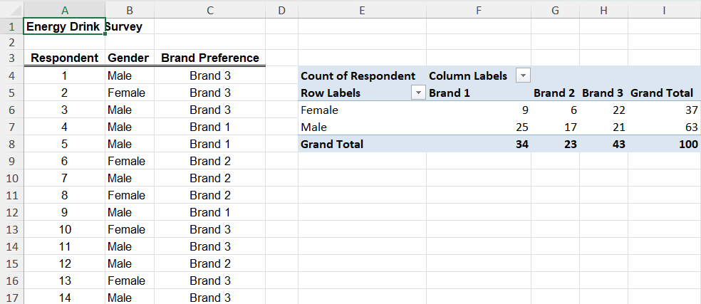

This is a summary of the dataset, the table in the right-hand corner shows the number of men and women along with the total number of drinks they consume. This table is also the table of theoretical values.
As a result on the figure, it can be seen that the total number of users choosing brand 1 is 34, brand 2 is 23, brand 3 is 43. The total number of females using all 3 brands is 37 and for males it is 63. Thus, the number of men and women in this dataset is 100 people in total.
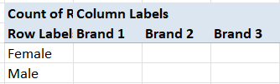

First, create an expected value table that contains no values at all.
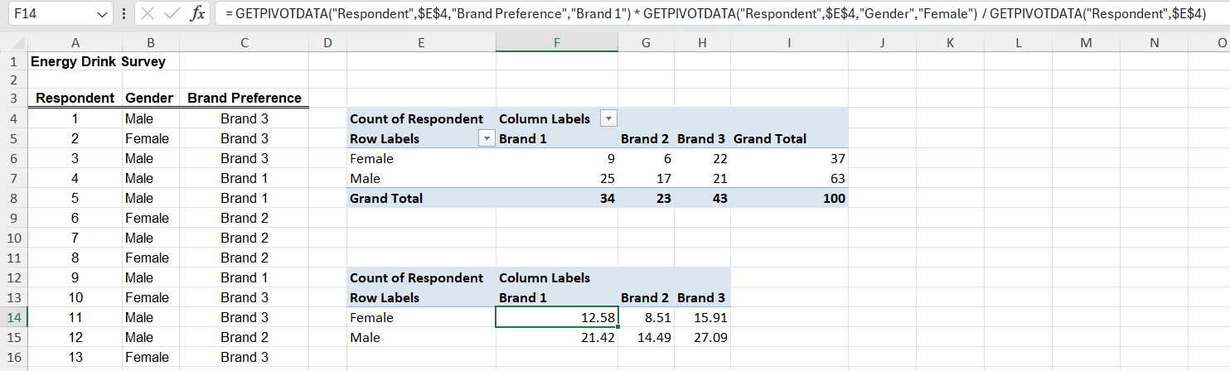

To calculate the expected value of each object, execute the excel statement as above. The details of the formula are as follows: Grand Total of Brand X * Grand Total of Y / Sum of Grand Total/ where x represents the value from 1 - 3 and y represents the male and female sexes.
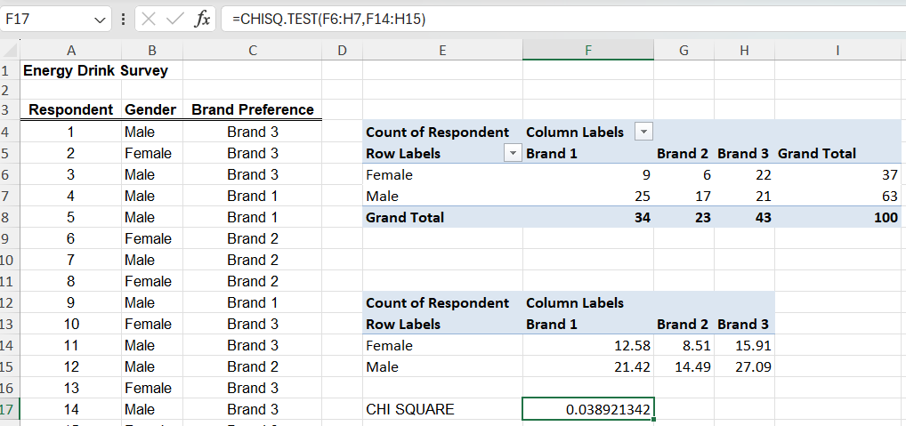

To perform the test, use the function in excel with the syntax: CHISQ. TEST(actual_range, expected_range). In this article, the formula is represented as follows: =CHISQ. TEST(F6:H7,F14:H15). The p-value = Chi-Square test above < 0.05.
=> Reject H0 - which means that the variables are unrelated and providing support for the H1 that the variables are related.
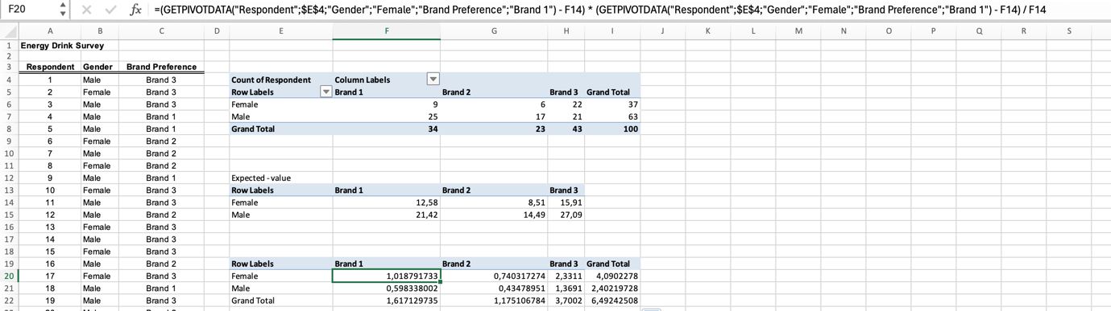

Chi-square = 6.49242508
This is a result after calculating chi-square using the formular below:
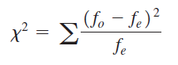

Where:
Χ²: the chi-square test statistic
f_{o} : observed frequencies
f_{e} : expected frequencies
The degrees of freedom (dof): (number of variable 1 groups − 1) * (number of variable 2 groups − 1).
dof = (2-1) * (3-1) = 1* 2 = 2
Significance level (α): 5% = 0.05
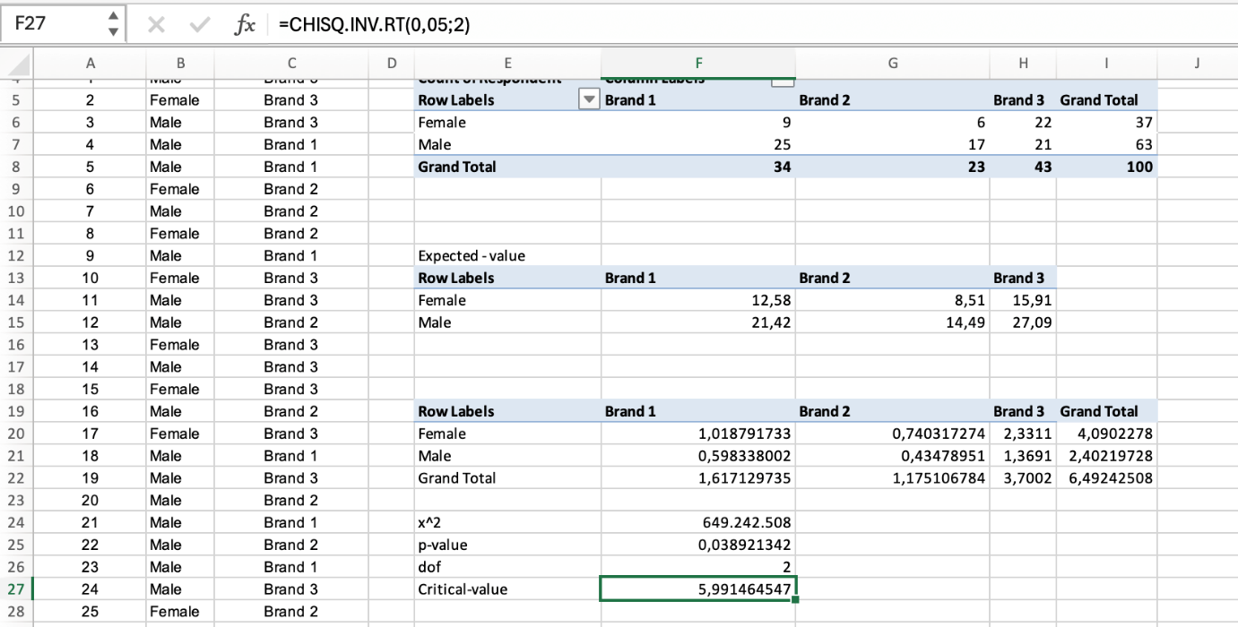

Calcultae the critical value by using CHISQ.INV.RT(df, ). X² > Critical value
=> Rejecting H0 which means that the variables are unrelated and providing support for the H1 that the variables are related.

1.3.2 Using Python
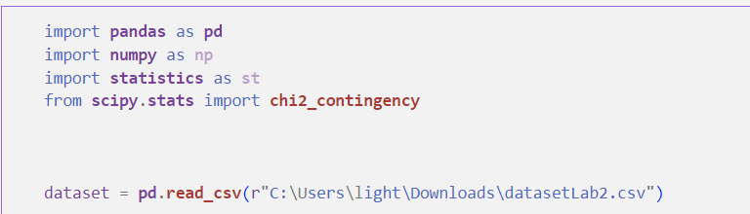
Figure 2 Import data and necessary library
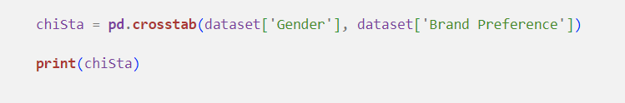
Figure 3 Create contingency table
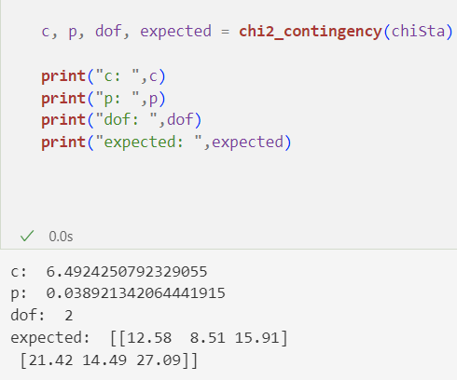
Figure 4 c-value, p-value, degrees of freedom, expected of the test

1.3.3 Using R
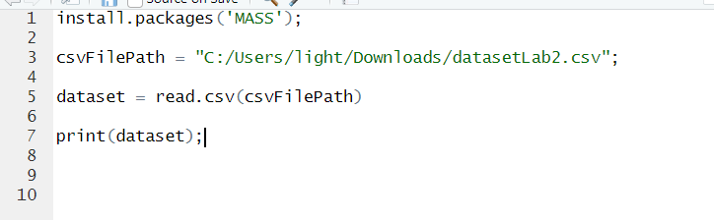
Figure 5 Import dataset and install necessary library
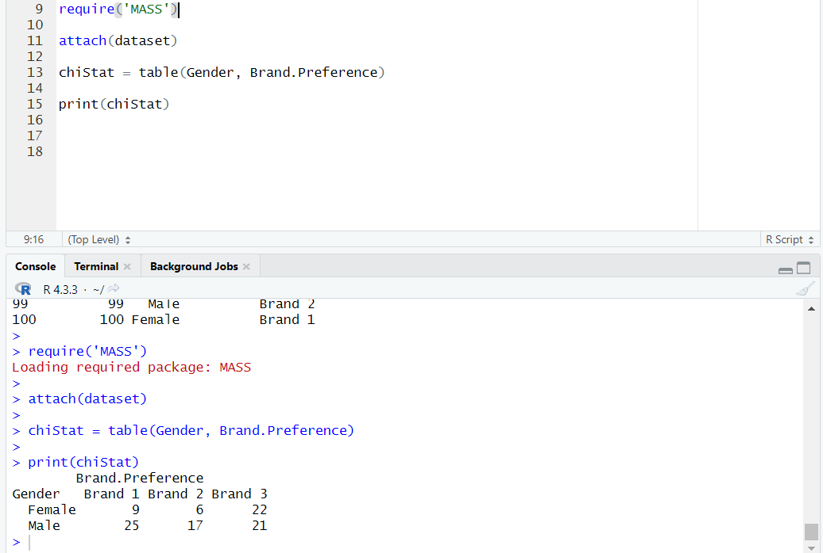
Figure 6 Create contingency table
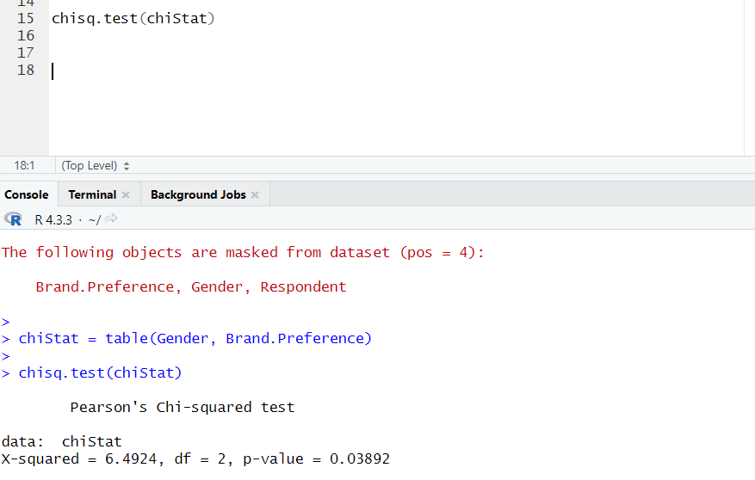
Figure 7 c-value, p-value, degrees of freedom

1.4 Perform ANOVA with Insurance survey dataset

1.4.1 Levene’s Test

1.4.1.1 Using Python
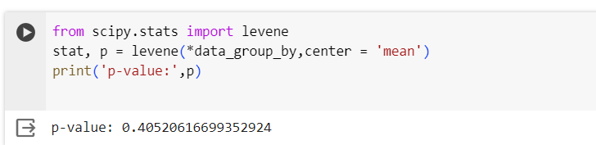
- P-value < 0.05 => reject H₀ => able to do Anova test

1.4.1.2 Using R
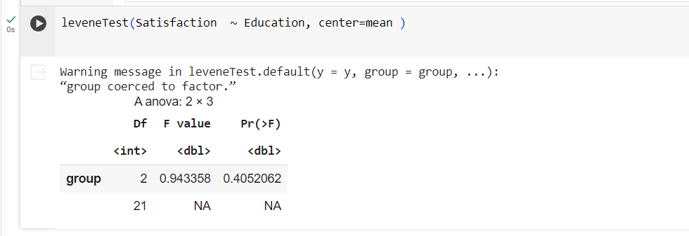

1.4.2 Anova’s Test

1.4.2.1 Using Excel
- Use ANOVA Single Factor feature of Data Analyze to get Sumary
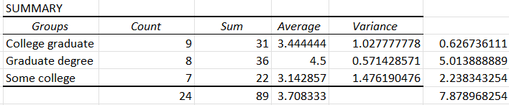

+ At the end of Count and Sum column , calculate sum of each column ( 24 and 89)
+ Get average of all value by getting value from Sum divide Count ( 89 / 24) and result is 3.708333
+ At the last column , calculate SS of each group and SSG in anova is sum of them (7.878968254)

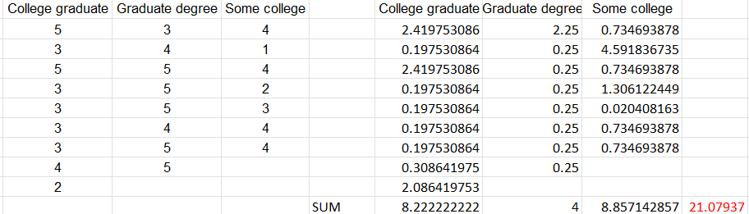
- Next , use average of summary to calculate SSW

+Calculate SS of each group and get sum of them , then SSW is 21.07937
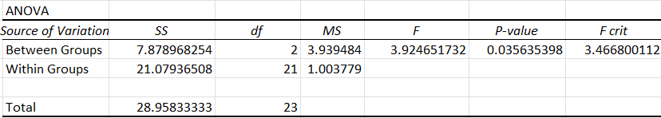
- Finally , get ANOVA:

+ Between Groups is SSG
+ Within Groups is SSW
+ Get df of Between Groups and df of Within Groups
  - n = 24 , k = 3
  - SSG: df = k – 1 = 3 -1 = 2
  - SSW: df = n – k = 24 – 3 = 21
  - Total = 21 + 2 = 23
+ Calculate MS ( MS = SS / df )
- SSB: MSG = 7.878968254 / 2 = 3.939484
- SSW: MSW= 21.07936508 / 21 = 1.003779
+ F = MSG / MSW = 3.924651732
+ To calculate F crit , use formula: =F.INV.RT(probability, df_between, df_within)
  - probability: This is the significance level (alpha) at which you want to find the critical value. A common choice is 0.05 (5%).
F crit= F.INV.RT(0.05, 2, 21) = 3.466800112
+ Similar to F crit , use formula for calculating (F.DIST.RT), but first parameter is F
P-value = F.DIST.RT(F, 2, 21) = 0.035635398
- Conclude:
  - P-value = 0.035 < 0.05 => Reject H0
  - F > F crit => Reject H0
    - So two categorical variables are dependent

1.4.2.2 Using Python
- Get input from Insurance survey dataset and use scipy library to calculate
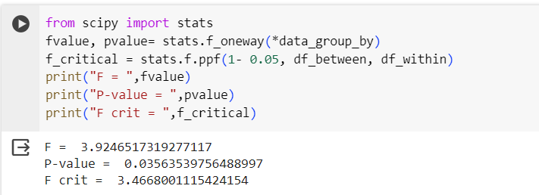
P-value = 0.035 < 0.05 => Reject H0
F > F crit => Reject H0

1.4.2.3 Using R
- Use car library to calculate

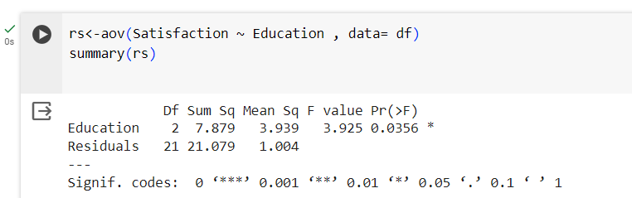

+ P-value = 0.035 < 0.05 => Reject H0
+ F > F crit => Reject H0

1.4.3 Turkey Test

1.4.3.1 Using excel

- Number the groups:
  - College graduate : 1
  - Graduate degree: 2
  - Some college: 3
- Calculate average variation range ( D_{ij} = |N_{i} – N_{j} |)
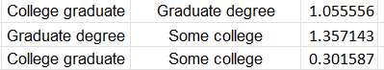

  - D₁₂ = 1.055556
  - D₂₃ = 1.357143
  - D₁₃ = 0.301587
- Turkey value :
  - k = 3 , n = 24 , α = 0.05, n_{min} = 7
  - T = q₍α_{,k,n-k)} √( MSW/n_{min} )= 3.56 * √( 1.00377928949358 / 7)=1.348093744
- Conclude
  - D₁₂ < T => accept H₀
  - D₂₃ > T => reject H₀
  - D₁₃ < T => accept H₀

1.4.3.2 Using Python

- Use statsmodels library to calculate
  - 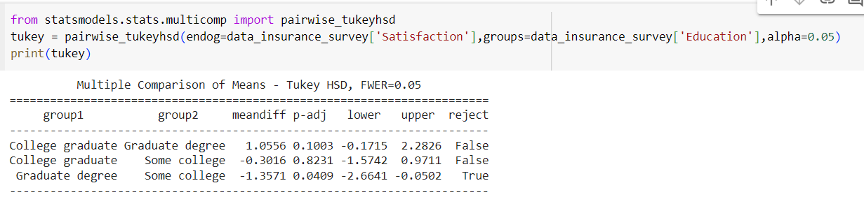Meandiff : The mean difference between the groups.
  - P-adj : The p-value for the test of whether the mean difference is significantly different from zero.
  - lower and upper bounds of the 95% confidence interval for the mean difference.

- As result , only pair of Graduate degree and Some college reject H₀

1.4.3.3 Using R
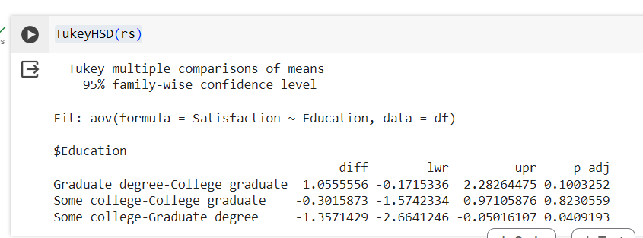

- Smililar to using Python , pair of Graduate degree and Some college reject H₀

1.4 ANOVA with Vietnam National Highschool Score 2023 dataset
- Dataset description: the dataset contains the scores of 1.5 million high school students in Vietnam who took the 2023 National High School Graduation Exam.
- Dataset structure:
- Student ID: Unique identifier for each student
- Mathematics: Scores in the Mathematics subject
- Literature: Scores in the Literature subject
- Foreign Language: Scores in the Foreign Language subject
- Physics: Scores in the Physics subject
- Chemistry: Scores in the Chemistry subject
- Biology: Scores in the Biology subject
- History: Scores in the History subject
- Geography: Scores in the Geography subject
- Civic Education: Scores in the Civic Education subject.
- Foreign Language Code: Code representing the chosen foreign language
ANOVA Test Hypothesis:
- Null Hypothesis ($H_{0}$): The means of the 'Mathematics' scores are the same across all categories of 'literature_classification'. This means the 'literature_classification' has no effect on the 'Mathematics' scores.
- Alternative Hypothesis ($H_{1}$): At least one 'literature_classification' category has a different 'Mathematics' score mean than the others.

1.4.1 Using Python
During the examination, some students didn't take the test for some reasons which make their score for that subject "NaN". To make these records not affect on the result, we will drop NaN value of Mathematics score and Literature score records.

Besides, we created a new column named "literature_classification" to classify the literature score of student bases on following rules:
- Excellent: 9 to 10
- Very good: 8 to 9
- Good: 7 to 8
- Average: 6 to 7
- Weak: from 5 to 6
- Poor: below 5
After that, we group the unique classification value with the list of Math score
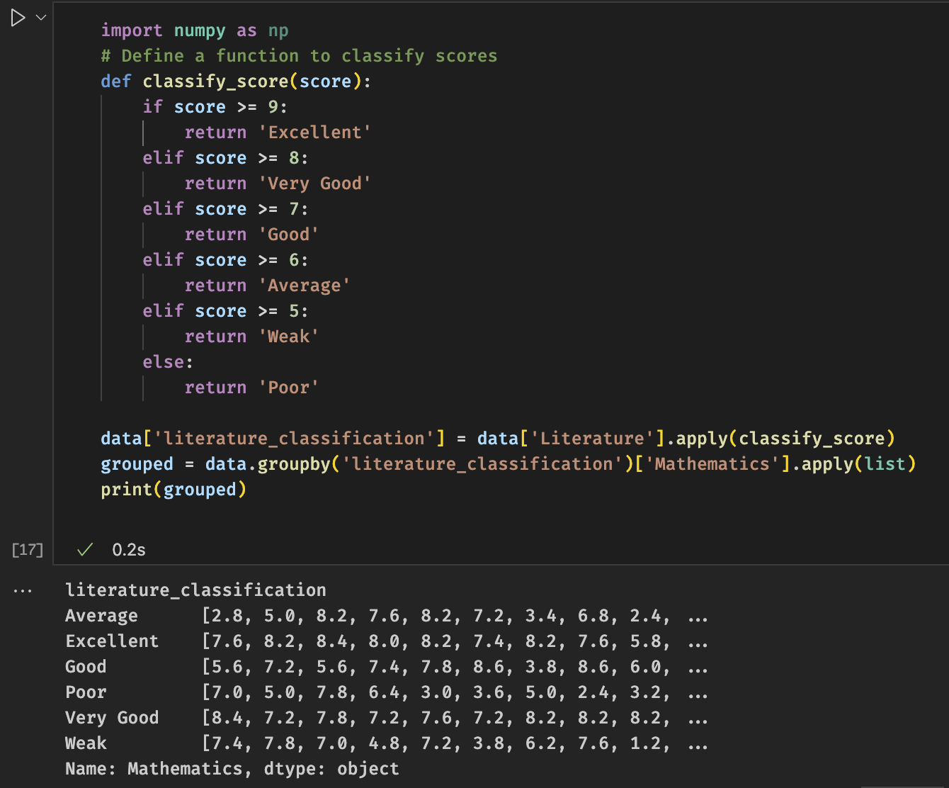
Figure 8. Preview data after processing
One-way ANOVA test
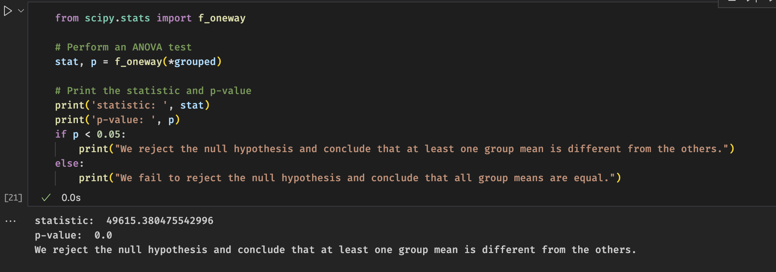
Figure 9. The summary of ANOVA test
Result evaluation:
49615 was a large f-statistics value which suggests that there is a significant difference between the means of the groups.
p-value of 0.0 suggests that the observed difference in group means is highly unlikely to have occurred by chance.
As p-value < 0.05, we reject the null hypothesis and conclude that at least one group mean is different from the others. This means that the literature score classification appears to have a significant effect on the mathematics scores.

1.4.2 Using R
Similarly, import data from CSV file and drop NA value for preprocessing data.
After that, add "literature_classification" column and print preview data.
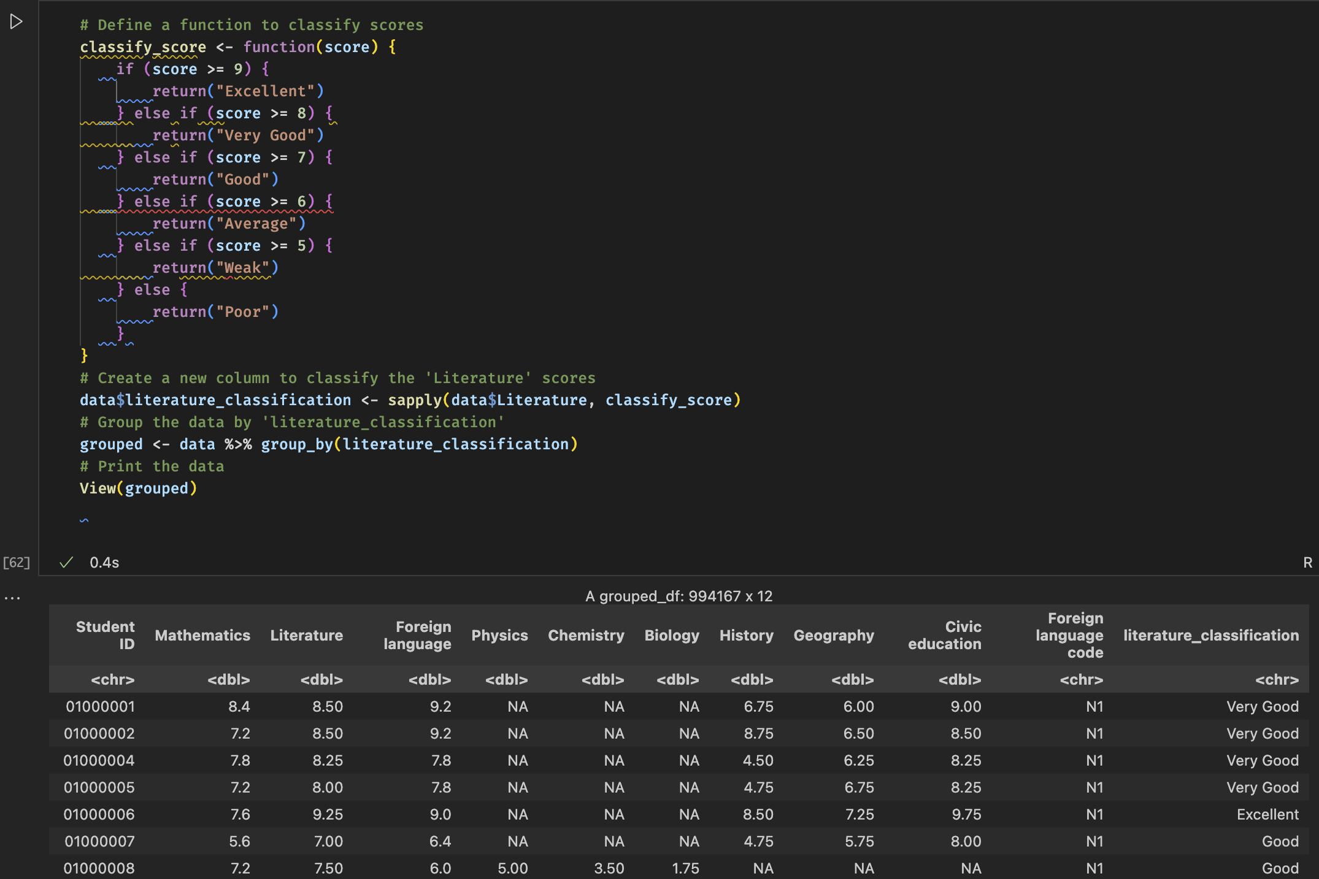
Figure 10. Preview data after processing
In R language, to performed ANOVA test, we used aov function. There are two params to fill in aov function:
- formula: This is a symbolic description of the model. For example, Mathematics ~ literature_classification means that the testing is about the effect of literature_classification on Mathematics.
- data: This is the data frame containing the variables in the model.

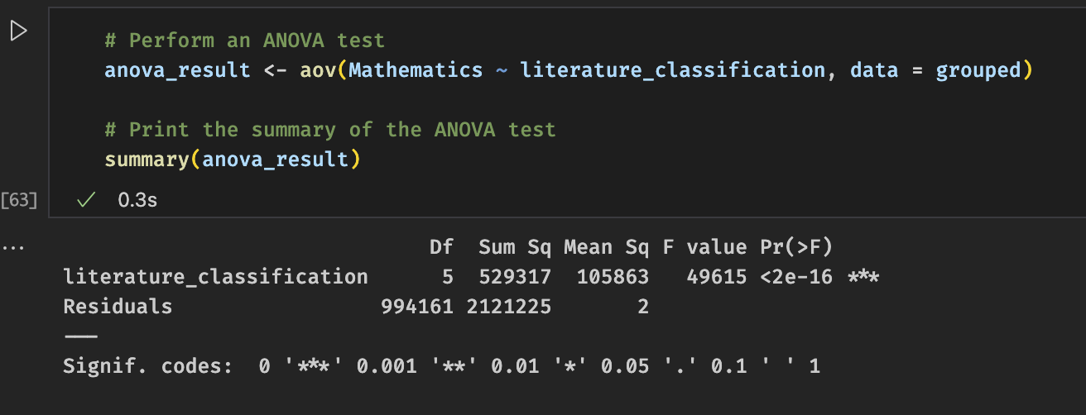
Figure 11. The summary of the ANOVA test
The summary function in R provides a summary of the results of an ANOVA test:
- The Df (Degrees of Freedom): This is the number of values in the final calculation of a statistic that are free to vary.
- Sum Sq (Sum of Squares): This is the sum of the squared deviations from the mean.
- Mean Sq (Mean Square): This is the average of the sum of squares, calculated as Sum Sq divided by Df.
- F value: This is the test statistic for the ANOVA test. It's calculated as the mean square between the groups divided by the mean square within the groups.
- Pr(>F): This is the p-value associated with the F statistic. It's the probability of observing a result as extreme as the one that was actually observed, assuming that the null hypothesis is true.
Result evaluation: The ANOVA test using R language returned the equivalent F-value when using python, the p-value also indicate very strong evidence to reject the null hypothesis.

REFERENCE
F-Distribution Table used in University of California (UCLA)
How to Perform ANOVA in Python (Explanation and example)
ANOVA in R | A Complete Step-by-Step Guide with Examples
N.Đ.Thuân. (2023). Chapter 7: Statistical Inference”.page 36, Business data analysis.
N.M.Nhut. (2023.). LAB02. INFERENTIAL STATISTICS”.page 9, IS403 – Business data analysis, UIT.
N.M.Nhut. (2023). LAB02. INFERENTIAL STATISTICS”.page 12-17, IS403 – Business data analysis, UIT.

